Rc, Psi(Rsum)

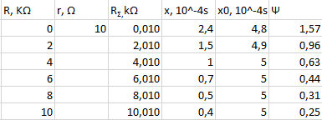

Rc, COT(PSI) = f(OMEGA\*R\*C)

Theor

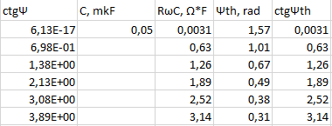

2) RL

PSI(R)

COT(PSI) = f(R/OMEGA\*L)

ABS(PSI) = f(NU/NU0)

